**DSA Assignment – 4th July**

**Name – Karan Joshi**

**Roll No. – 23/11/EC/036**

**Leetcode Id – Karan_Joshi068048**

**Geeksforgeeks Id – wwwjoshikaran3424**

**Github Repo Link -** [**https://github.com/KaranJoshi101/urban-octo-robot/**](https://github.com/KaranJoshi101/urban-octo-robot/)

DSA-Section -

Question 1: Find the Celebrity

Platform: LeetCode

Problem Link: <https://www.geeksforgeeks.org/problems/the-celebrity-problem/1>

Submission Screenshot:

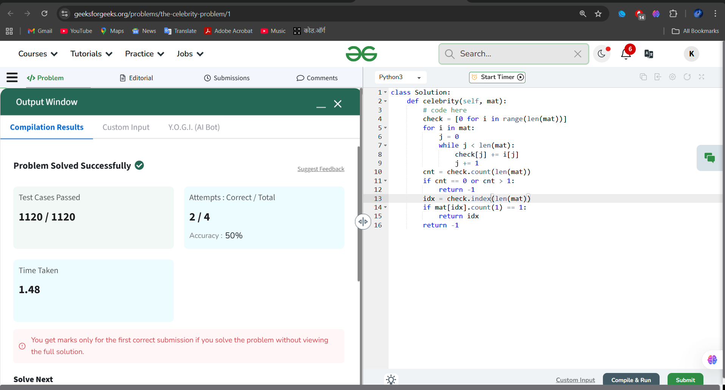

Question 2: Trapping Rain Water

Platform: LeetCode

Problem Link: <https://leetcode.com/problems/trapping-rain-water>

Submission Screenshot:

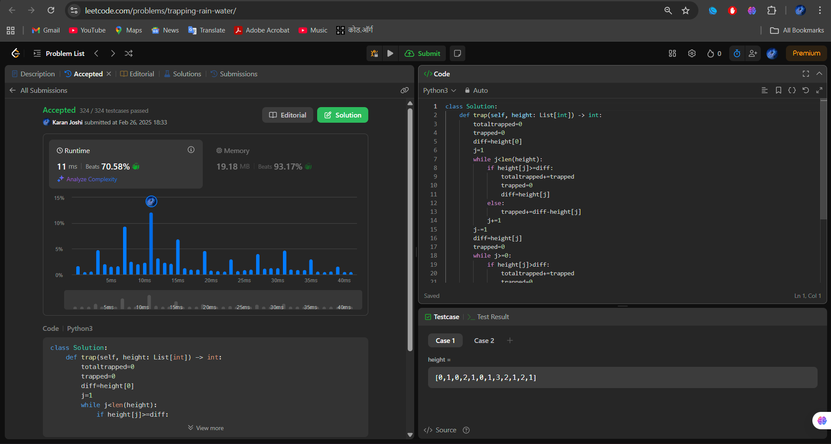

Question 3: Design LRU Cache

Platform: LeetCode

Problem Link: <https://leetcode.com/problems/lru-cache/description/>

Submission Screenshot:

